For your retrospective, here is the rubric. Please identify things that you did well as a team, things that need improvement as a team, and how you will make those improvements happen. You should do this together as a team to ensure discussion, but each student will turn in his/her own copy of this.

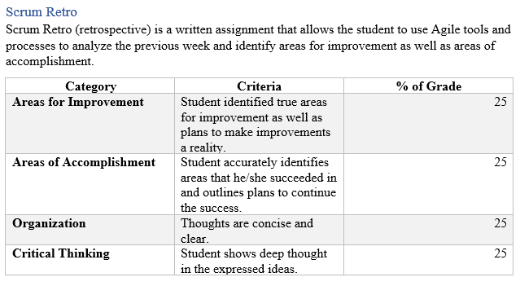

Over the past few weeks we as a group we have identified a few different areas for improvement. We noticed that our communication is probably the strongest weakness that we have. We decided as a group that we could resolve this by announcing on slack when we are working on the project so that other group members could chime in if they have time. We also decided that we would try to organize zoom meetings so that we can work as a group for different remote locations. Also, we would announce project updates as often as possible. We also noticed that we as a class did not define what we were actually going to work on the project so that created confusion and a stalemate causing no one to get any work done. To get these problems corrected we decide that we would communicate as much as possible and try to work together more. After we made these changes we achieved a few different accomplishments. We started having weekly group sessions, our project is continually progressing, and we as a group have been able to troubleshoot various problems and make the changes needed to correct them. Working by myself, I found that I struggled with trying to decide what I was going to do for the project. I think this caused me to take the project into my own hands and get stated so that other group members could help when they got time.

Each student will do their own RCA individually. Please identify areas you had difficulty with, or ran into errors/exceptions while coding, and identify how you overcame these difficulties. Include links to resources used to overcome the issues.

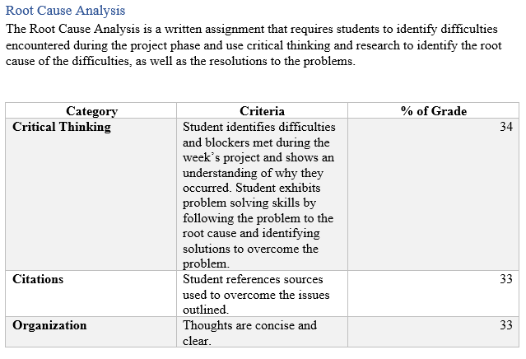

While working on this weeks project, I noticed that I struggled the most with git hub. Trying to figure out the correct forms of pushing and pulling was a struggle for me. I used github’s help page to get through most of these problems or I used my peers in slack to get the help I needed. Most of the time those I was able to google it and get the correct form of what I needed to do. Once I got the files uploaded my work in eclipse was throwing a few different errors. Most of these errors were solved quickly with the help tools in eclipse. Another big problem I faced was trying to work on my patience as I worked with the other group members. I definitely need to work on my patience.

https://help.github.com/articles/adding-an-existing-project-to-github-using-the-command-line/